

Annual Meeting, Rock Creek Resort

Red Lodge, Montana, August 14-16, 2018

(Approved for 8 ARPAS CEU’s)

**FEATURED SPEAKERS:**

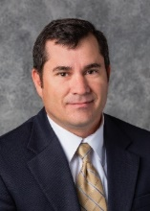**Sean Kelly**

Sean Kelly, SDSU Extension Range Field Specialist resides in Gregory, South Dakota with his wife Tracy. Sean received his BS degree in Range Science from SDSU in 2006 and his MS in Ranch Management from Texas A&M University-Kingsville, King Ranch Institute for Ranch Management in 2008. Sean’s research thesis was conducting financial and economic analyses for the Padlock Ranch of Ranchester, Wyoming. Today, Sean spends the majority of his time promoting sound rangeland management practices through 1-on-1 consulting.

**Nicole Rolf**

Nicole Rolf is the National Affairs Director and Eastern Montana Regional Manager for the Montana Farm Bureau Federation (MFBF). She works in public policy and agriculture advocacy on the state and national level, representing the farmer and rancher members of MFBF in the state Legislature and Congress. She works directly with the grassroots membership of Farm Bureau, helping members achieve their organizational goals. Nicole joined the staff of MFBF in 2007 after obtaining her BS degree in Agricultural Business from Montana State University. Nicole and her husband live on their ranch east of Miles City with their two-year-old son.

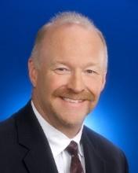**Brian Rittgers**

Brian Rittgers, Director of Ruminant Business for Micronutrients USA. Prior to Micronutrients Brian spent 37 years with Elanco Animal Health. Rittgers received his BS degree in Agriculture Business from Iowa State University in 1979. He is past Chairman of the Board of AFIA and currently serves on the Past Chairmen Committee. He also serves on the Cal-Poly University Animal Science Department Board of Advisory Council. Brian and his wife Pat live in Zionsville, Indiana and are the parents of two grown children, Chris and Paige.

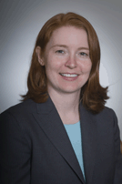[**Leah Wilkinson**](mailto:lwilkinson@afia.org)

AFIA Vice President, public policy and education. She interacts with state legislatures, feed regulatory agencies in the Western U.S., the Association of American Feed Control Officials and the U.S. Food and Drug Administration. Wilkinson also works with the AFIA Feed Regulatory, Ingredient Approval and Definitions and Pet Food committees.

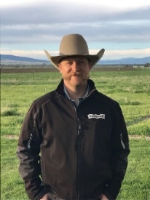**Cash Yount**

Cash Yount is a Nutrition Consultant for CHS Nutrition out of Great Falls, MT. He helps carry on Montana agriculture by helping to build feedlot diets, formulate mineral programs and deliver nutrition advice to Western Montana’s beef producers. He specializes in cow calf operations, but gets to help with a wide array of production agriculture including Emu! Cash lives in Deer Lodge, MT where he was born and raised, with his wife Alisha and two daughters, Gracie and Logan. Cash has a passion for the industry and securing an opportunity for agriculture for many generations to come.

**AGENDA:**

**Tue. 8/14/18:**

5:PM Red Lodge Ales Brewery tour

**Wed. 8/15/18:**

7:AM Breakfast in hotel cafe area 8:AM Dustin C. Suess – Welcome

8:15AM John Gates – Message from our President 8:45AM Sean Kelly – Drought and Fire, A rancher’s perspective on preparation and recovery

9:15AM Nicole Rolf – Hot Ag Topics – Whats important to your customers

9:45AM Break

10:AM John Gates - MFA Business Meeting, Election.

12:00 Lunch

1:00 PM Golfers to 9-hole scramble, Fishermen and Fisherwomen to fly fishing.

6 PM Rock Creek Resort: Tri-Tip BBQ/ casting/chipping/scholarship auction/social

**Thu. 8/16/18:**

7:AM Breakfast in the hotel cafe area

8:AM Dustin C. Suess – Welcome

8:15AM Bob Church & Falina Hutchinson – MT Department of Ag 9:AM Brian Rittgers – Dealing with Objections 9:45AM Break10AM Leah Wilkinson – Federal Update

10:30AM Announcements/Sponsor appreciation – MFA Board

11AM Cash Yount – Adding ValYOU to Montana Agriculture

11:45 PM John Gates - Adjourn

New Board of Directors Meeting – open to all

**ACCOMMODATIONS:**

**PLATINUM:**

 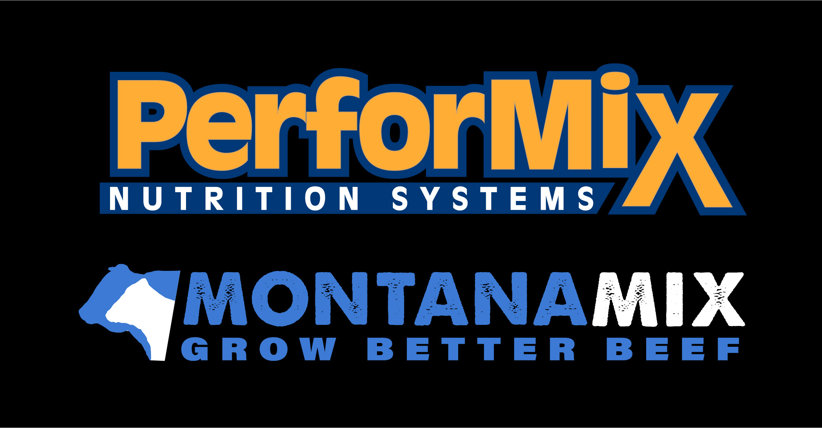

  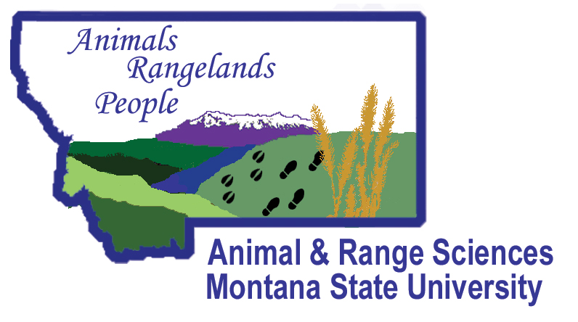

C:\Users\Admin\AppData\Local\Microsoft\Windows\INetCache\Content.Word\micronutrients-logo.png 

 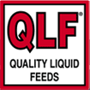

**GOLD:**

 

 



**SILVER:**

 

**BRONZE:**

**Rock Creek Resort (Meeting Site)** 6380 US-212, Red Lodge, MT 59068[**reservations@rockcreekresort.com**](mailto:reservations@rockcreekresort.com), (800) 667-1119, ask for “**MT Feed Association**” rates before 7/13/18.

**Comfort Inn** 612 North Broadway, Red Lodge, MT, 59068 (406) 446-4469

**Sponsorship Opportunities:**

**Platinum $400**

**Gold $300**

**Silver $200**

**Bronze $125**

Sponsorships showcase your company, keep registration costs low and defray costs of golfing and fishing events. They also support the quality of our program and our **MFA scholarships.** These competitive, merit scholarships are awarded at the Montana Nutrition Conference held in Bozeman every April (co-sponsored by MFA and Montana State University) to undergraduate students from the MSU College of Agriculture. This supports careers in livestock production and agribusiness. Your generosity makes this possible and is greatly appreciated.

**2018 SPONSORS**



**August 14-16, 2018 Annual Meeting**

**Rock Creek Resort, Red Lodge Montana**

(Approved for 8 ARPAS CEU’s)

**Registration Information:**

**Company**

**Registrant Name**

**Spouse’s Name**

**Address**

**City, State, Zip**

**Email**

**Attendee RSVP (checkmark interests):**

**BBQ 󠄀** **Golf**  **Fishing Brewery Tour**

**RSVP for Spouse:**

**BBQ**  **Golf**  **Fishing Brewery Tour**

**Registration at the door $225.00 _____**

**Pre-Registration Fee $215.00 _____**

**Spouse Registration Fee $115.00 _____**

**BBQ and Brewery tour only $50.00 _____**

**Sponsorship: _____**

**Total: _____**

**Please RSVP by 7/27/2018**

**Mail Registration Information with check payable to: Montana Feed Association**

**2075 Charlotte St.**

**Ste. #2**

**Bozeman, MT 59718**

**Or email: montana.feed@gmail.com**